User Manual

xxx

xxx

xxx

xxx

xxx

(blur the names since PII)

Content

1. Program overview 3
   1. Program background 3
   2. Program target 3
   3. Application procedures 3
2. Module description 4

2.1 Add/Edit Machine Profile 4

2.2 Pre-view sales 9

2.3 Process daily sales 10

2.4 Product daily sales analysis 12

2.5 Quit the program 13

1. Program overview
   1. Program background

As the number of vending machines is increasing, sales department has a heavy duty of maintenance, replenishment, and sales analysis. Therefore, a program to help the staff do things mentioned above is in great need.

* 1. Program target

This program is to be used by the staff in the Sales Department to support re-fill requirements and sales analysis.

* 1. Application procedures

This program has four main modules corresponding to four different purposes: modifying vending machine profiles, previewing sales data, integrating sales data, and plotting data for sales analysis.

1. Module description

Main program shown as below

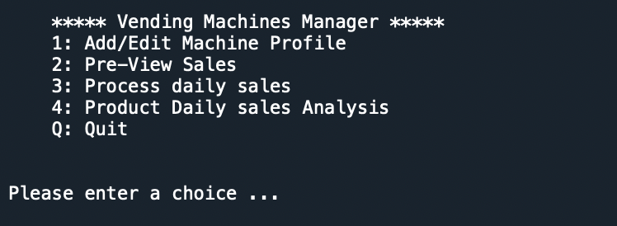

* 1. Add/Edit Machine Profile

User can input 1 and press enter to enter *Add/Edit Machine Profile* module. This module has 2 functions. The first function is used to display the machine information. User can input machine ID and press enter, and then program will return and show information such as: slot ID and product ID on the screen. (Example shown below, yellow mark input)

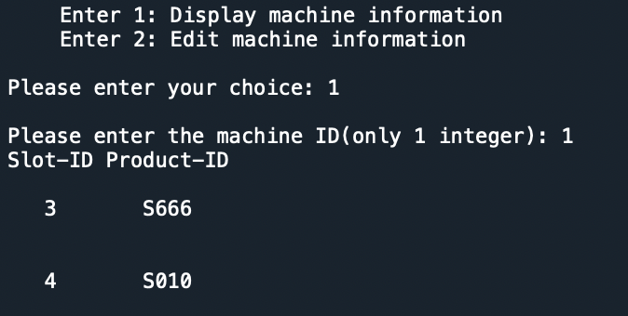

The second function is to edit machine profiles. User can change slot ID, remove slot information, and even delete entire machine profile.

User can add slot ID and product ID to the machine which is chosen. The input slot ID and product ID will be added directly if master file doesn’t have the same slot ID and product ID. Program will automatically append machine ID, slot ID and product ID at the end of file. (Example shown below)

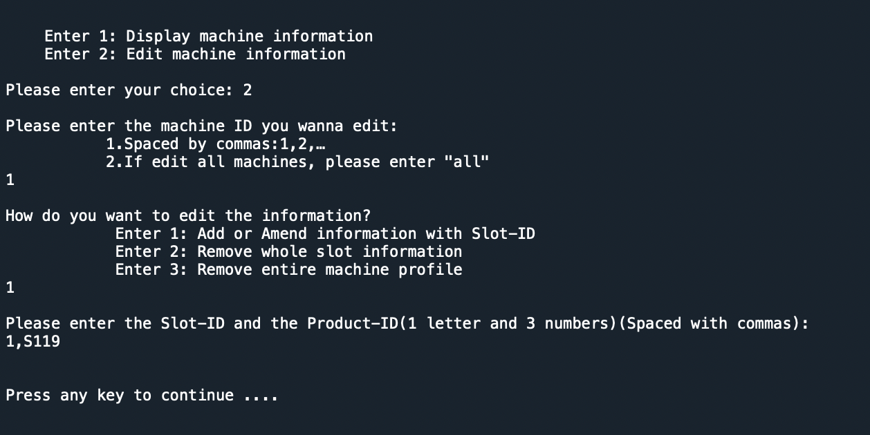

If master file already has slot ID, then the product ID that user has input will replace the original product ID. (Example shown as below about changing machine 1, slot 1, product id from S119 to S120)

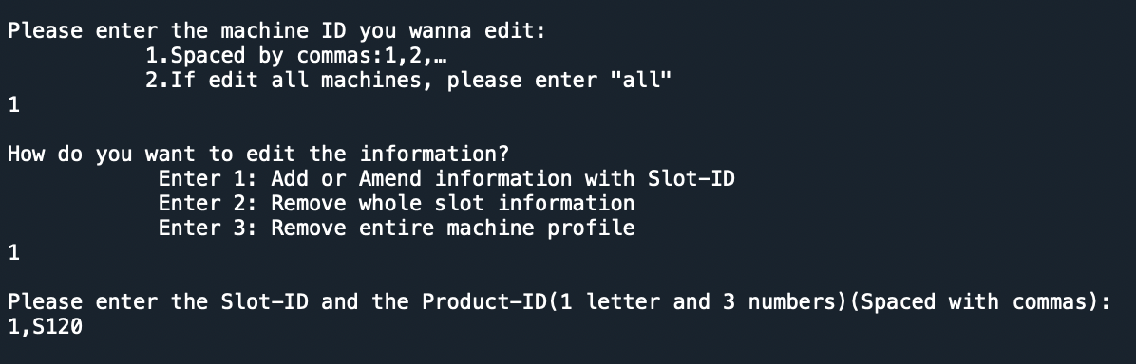

User can also remove whole slot ID and its information(Example shown as below)

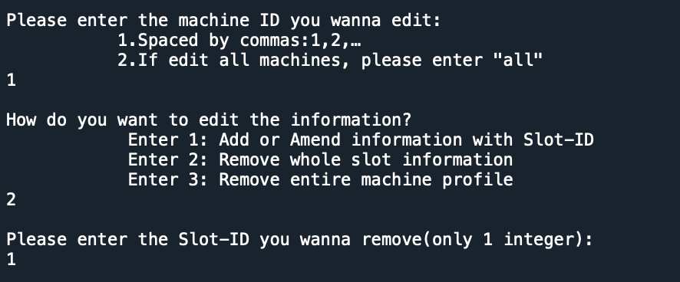

User can remove entire machine file (Example shown as below)

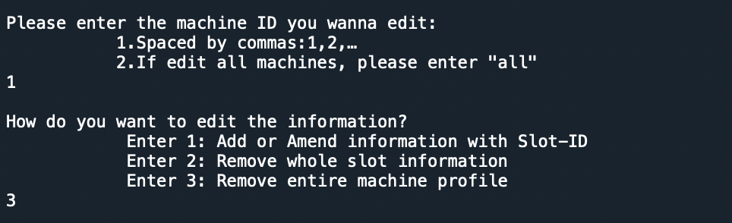

Machine 1 removed



User can also edit machine profile in batch processing by inputting several machine IDs separated by comma or just input ‘all’ to edit all the machine profiles. (Example shown as below)

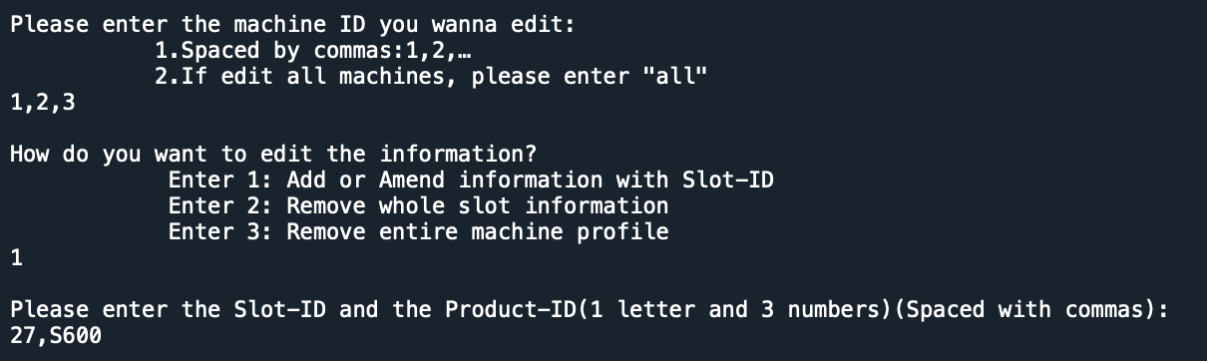

User can remove whole slot information in batch processing.

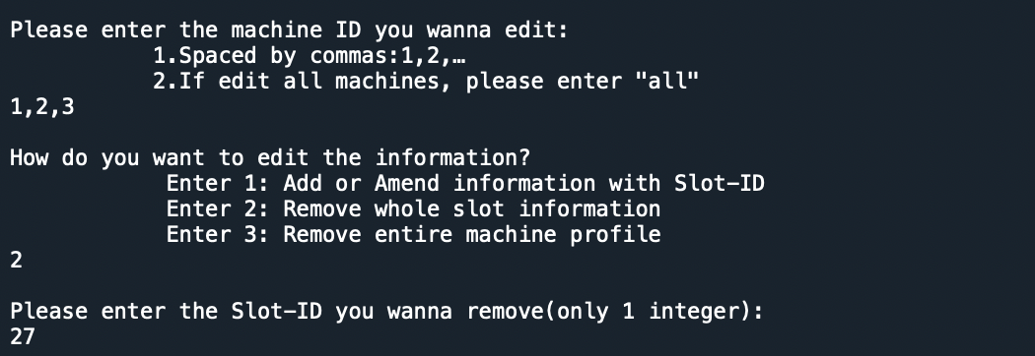

Slot 27 information removed



User can remove machine information in batch process



Machine 1,2,3 removed



Warning: User cannot edit machine information if there exist files to be processed in pending folder. (Example shown as below)

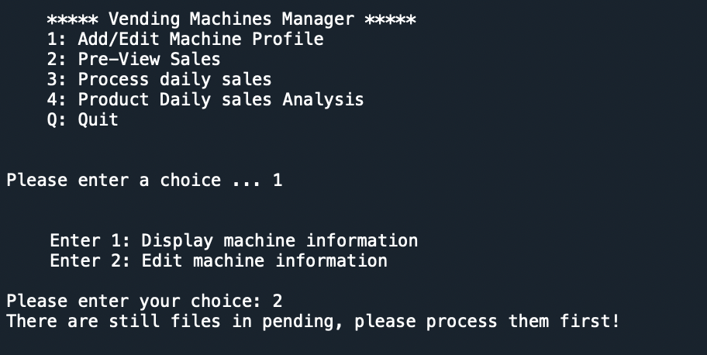

* 1. Pre-view sales

User can input specific date (format YYYY-MM-DD) to preview the integrated sales information. (Example shown below)

Show table like this

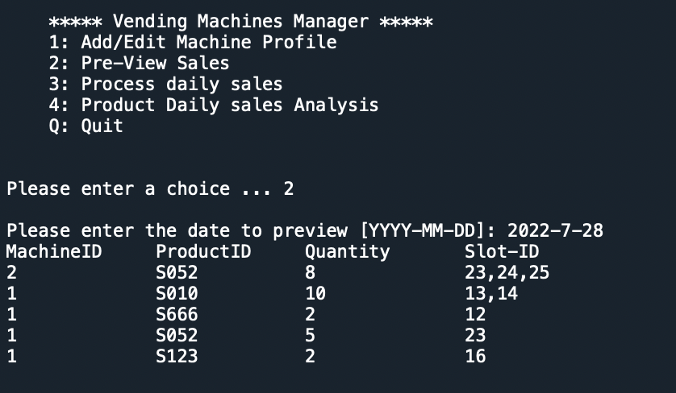

Warning: Invalid date input, or file not found will cause program return error message. Program will require user to input correct date information. (Example shown below)

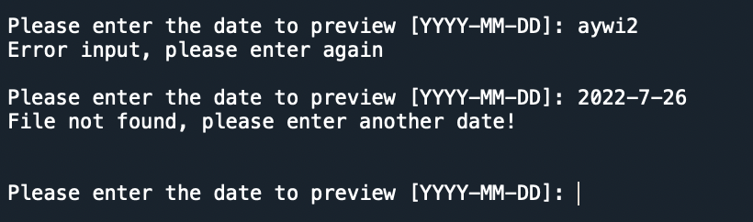

* 1. Process daily sales

User can use this module to integrate sales data into csv file (*SummarySales.csv*) by inputting the date (format YYYY-MM-DD). (Example shown below)

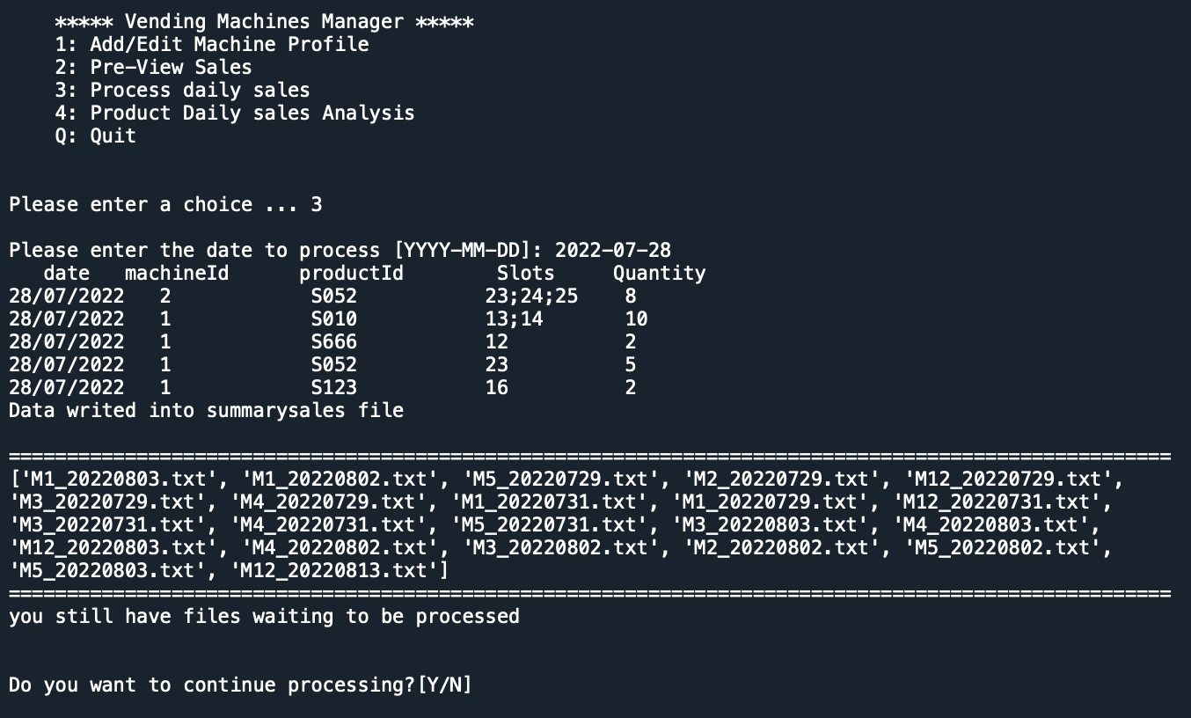

After processing the data, the files will be moved to a folder called *complete* from *pending* folder.

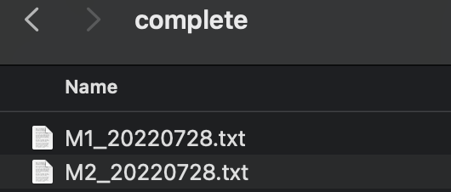

Reminder: If there is no *complete* folder, program will automatically make a directory called *complete* to place the processed files which are moved from *pending* folder. *SummarySales.csv* file has similar mechanism of creating.

* 1. Product daily sales analysis

User inputs year, month (format M or MM), and product ID to plot product sales condition (Example for sales of product S052 in July 2022 shown below)

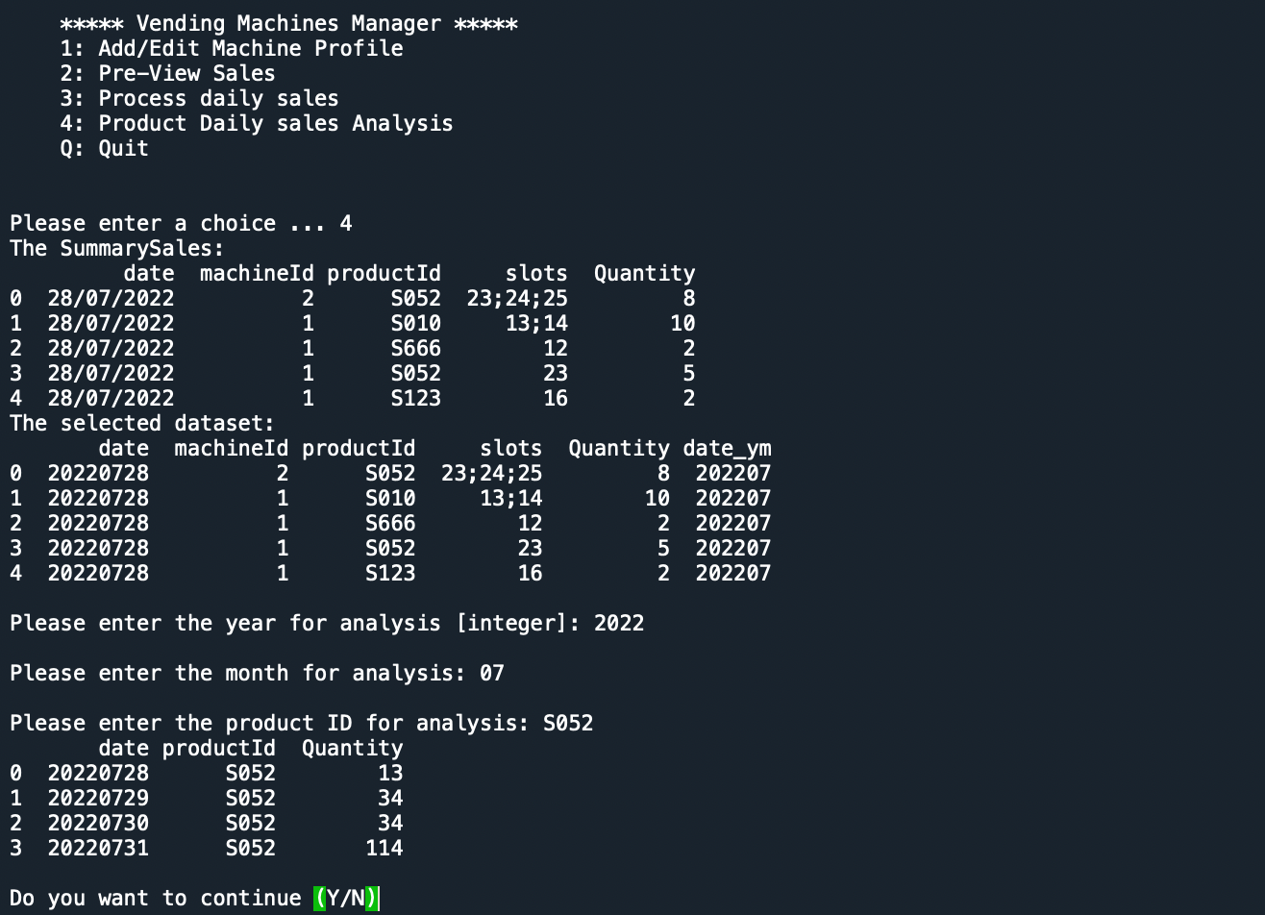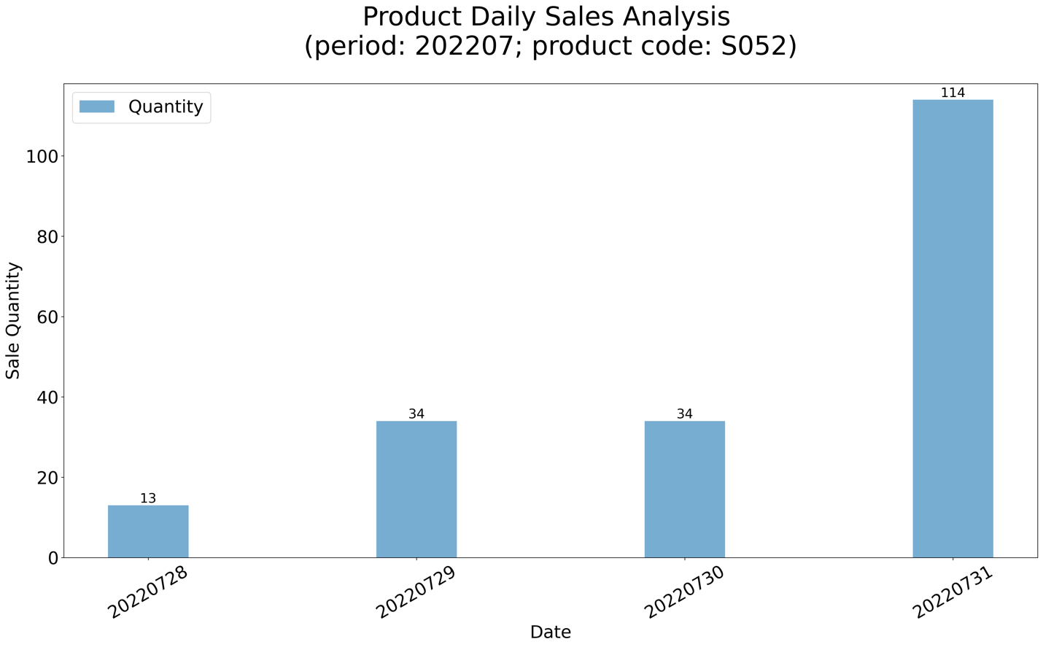

Reminder: If there is no *SummarySales.csv* file, program will remind user to process the pending files first (module 3) and then user can use *Product daily sales analysis* module successfully.

* 1. Quit

After operation, user can return to main page and enter Q to exit.